Architectural design

1. Conceptual architecture

* **Categorization:**

|  |  |  |  |  |
| --- | --- | --- | --- | --- |
| **Data** | **Function** | **Stakeholder** | **System** | **Abs. concept** |
| Places | Calculate | User | External services | Navigation tool |
| Databases | Add/Remove place |  |  | Map |
| Connections | Download |  |  | Route calculator |
| Users | User management |  |  |  |
| Preferences |  |  |  |  |
| Credentials |  |  |  |  |
|  |  |  |  |  |

* **Conceptual architecture with component stereotypes:**

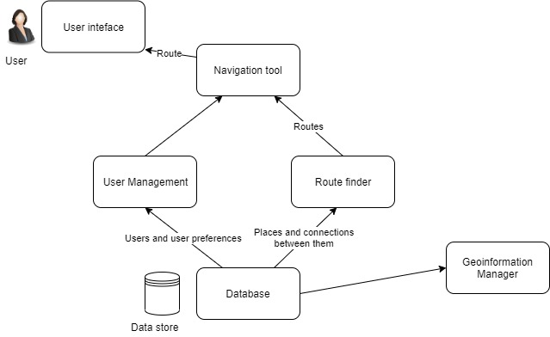

* Responsibilities of the components:
* User interface:
* Show places
* Display map
* Show route
* Navigation tool
* Calculate location on map
* Route finder
* Find route
* Geo information manager
* Add place
* Remove place
* Search place

1. Execution architecture

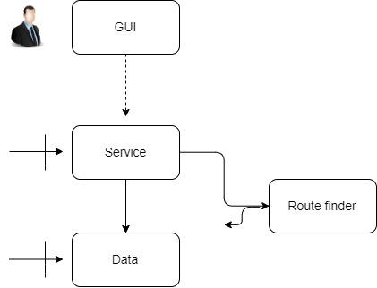

* **Binding of conceptual and execution architecture:**

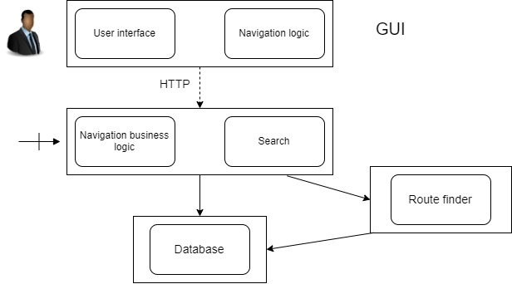

1. Implementation architecture

* **Implementation architecture using a sequence diagram:**

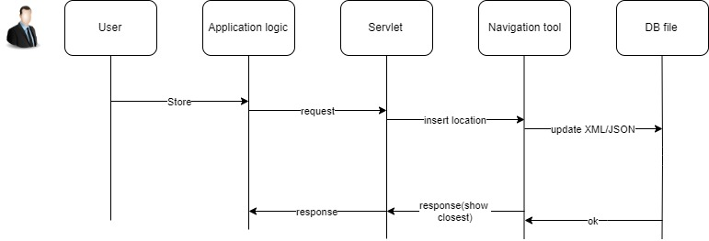

* **Impact-maps**

Map 1: The external system should change depending on the device used i.e. the interface of the external system should be changed.

Map 2: Directions to different locations may change over time with new roads being built, new locations being opened which may be closer in regards to the position entered, so the route finder should be regularly updated.

Map 3: The map should be updated in regards to construction projects, roads or shifting terrain.

Map 4: With different user preferences gaining popularity, the User Interface(UI)